**SQL Data Analysis Project**

**Moe’s Pizza Retail chain - Sales Data Analysis**

**Prepared by**:  
Shashank Singh

**Project Description**:  
This project focuses on the analysis of pizza orders of a popular pizza chain called “Moe’s Pizza”, using SQL to extract valuable insights from a relational database consisting of four tables: order_details, order_time, pizza_types, and pizza_price. The analysis addresses a range of business problems related to sales trends, revenue generation, and customer behavior. The findings are aimed at informing decisions on product optimization, pricing strategies, and customer satisfaction.

**Key Objectives:**

* Analyze order trends over time to uncover emerging patterns in customer behavior.
* Identify the most profitable pizza size and category combinations.
* Determine the top-selling pizzas and revenue contributions by type and size.
* Provide actionable insights to improve pricing, promotions, and overall business performance.

Project Link –

**Business Background**

In today’s competitive food service industry, understanding customer preferences and optimizing product offerings is essential for maximizing revenue and ensuring customer satisfaction. The pizza sector, in particular, experiences fluctuating demand based on various factors such as seasonality, promotional activities, and evolving consumer tastes. Businesses in this sector must leverage data analytics to uncover actionable insights from order data, allowing them to tailor their offerings to meet customer needs effectively.

This project focuses on a pizza restaurant chain that has been operating for several years. The restaurant has accumulated a wealth of data through customer orders, detailing various aspects of each transaction, including the types of pizzas ordered, their sizes, prices, and the timing of the orders. By analyzing this data, the restaurant aims to improve its operational efficiency, optimize pricing strategies, and enhance marketing campaigns tailored to specific customer segments.

**Business Problem Statement**

Despite the restaurant's consistent sales, Moe’s Pizza’s owner and his management has identified a gap in its understanding of customer behavior and preferences. Questions arise regarding which pizza types are most popular, how different factors like time of day and size affect sales, and what role various pizza categories play in revenue generation. Without a comprehensive analysis of their data, the restaurant risks making uninformed decisions that could hinder profitability and market competitiveness.

The business seeks to answer the following questions:

1. What are the trends in pizza sales, and how can they be leveraged to enhance product offerings?
2. How can the restaurant identify the most profitable pizza types and sizes?
3. What insights can be derived from order timing to improve operational efficiency, such as staffing and inventory management?

**Theory**

To address the identified business problem, the project utilizes SQL as a data manipulation and retrieval tool to extract valuable insights from the database. By structuring the data into four distinct tables—order_details, order_time, pizza_types, and pizza_price—the project implements various SQL queries designed to generate insights at different levels of complexity.

1. **Descriptive Analysis**: Basic queries provide foundational insights into total orders, revenue, and popular pizzas. This information serves as a benchmark for understanding overall performance.
2. **Inferential Analysis**: Intermediate queries facilitate deeper insights by revealing relationships between different data points, such as the correlation between time of day and order volume, or the breakdown of sales by pizza category. This analysis helps identify trends and patterns in customer preferences.
3. **Predictive Analysis**: Advanced queries enable the restaurant to forecast future sales trends, assess the cumulative impact of sales over time, and identify high-revenue pizza types. These insights can inform strategic decisions regarding menu optimization, targeted promotions, and pricing adjustments.

By systematically analyzing these aspects, the project aims to provide actionable recommendations that enhance the restaurant's ability to adapt to market demands, ultimately leading to increased customer satisfaction and profitability.

**Business Questions :-**

1. Retrieve the total number of orders placed.
2. Calculate the total revenue generated from pizza sales.
3. Identify the highest-priced pizza.
4. Identify the most common pizza size ordered.
5. List the top 5 most ordered pizza types along with their quantities.
6. Join the necessary tables to find the total quantity of each pizza category ordered.
7. Determine the distribution of orders by hour of the day.
8. Join relevant tables to find the category-wise distribution of pizzas.
9. Group the orders by date and calculate the average number of pizzas ordered per day.
10. Determine the top 3 most ordered pizza types based on revenue.
11. Calculate the percentage contribution of each pizza type to total revenue.
12. Analyze the cumulative revenue generated over time.
13. Determine the top 3 most ordered pizza types based on revenue for each pizza category.
14. Identify the average quantity of pizzas ordered per order
15. Analyze which combination of pizza size and category has highest contribution to our revenue
16. Analyze the trend of orders over time (average order quantities and revenue)

**Analysis and Findings: -**

1. Retrieve the total number of orders placed.

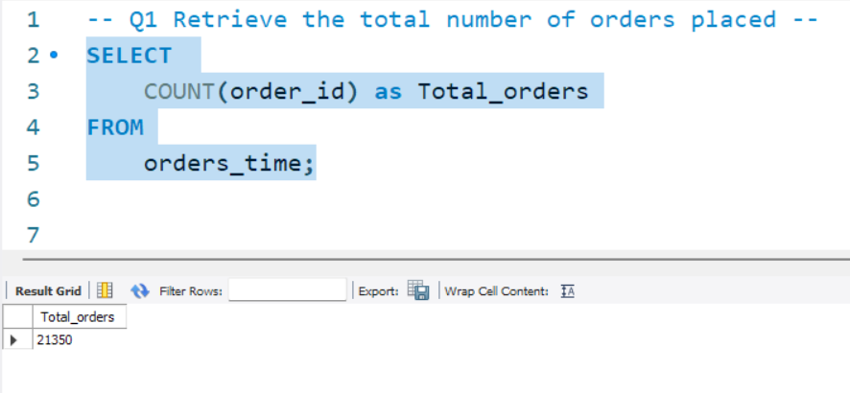

1. Calculate the total revenue generated from pizza sales.

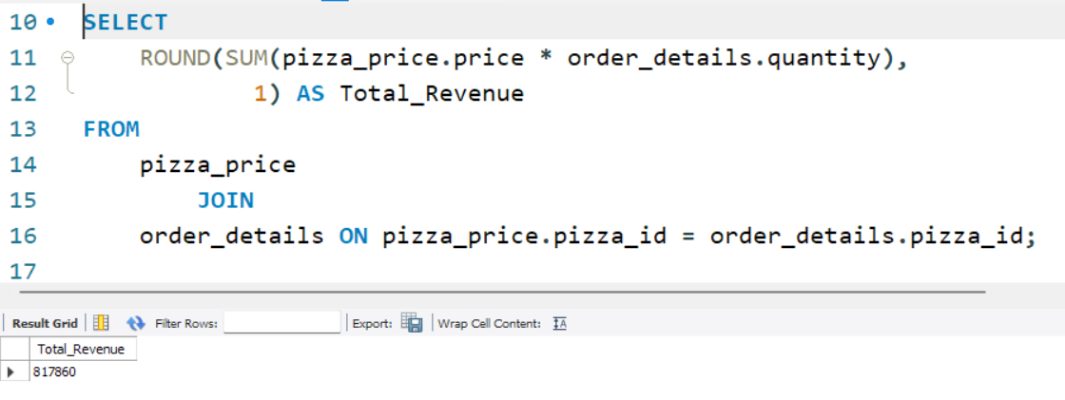

1. Identify the highest-priced pizza.

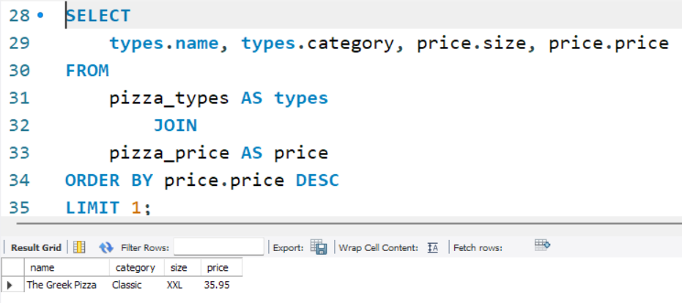

“**The Greek Pizza”** of the classical category is the highest priced pizza in the entire orders data.

1. Identify the most common pizza size ordered.

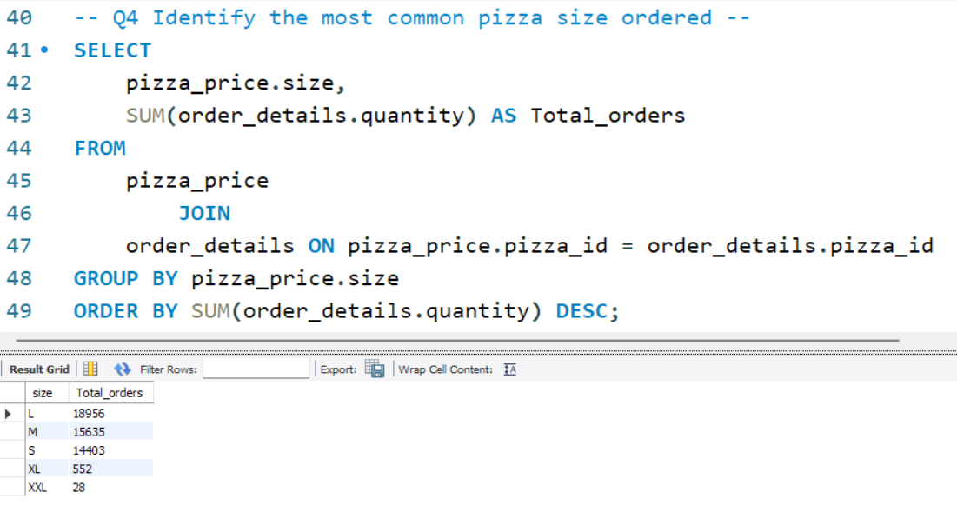

The most preffered size is the “L” size, which is large size. We should ensure that all pizzas have availability in “L” size.

1. List the top 5 most ordered pizza types along with their quantities.

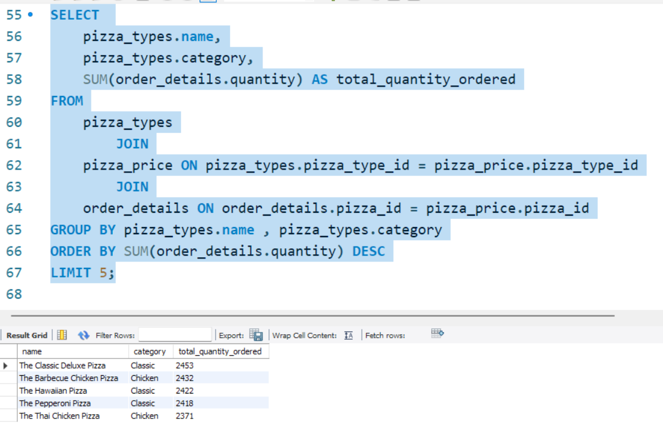

These 5 are the most commonly ordered pizzas, hence management should keep a good stock of their ingredients and we can increase our revenue if we increase the price of these five by 5% to 10%.

1. Join the necessary tables to find the total quantity of each pizza category ordered.

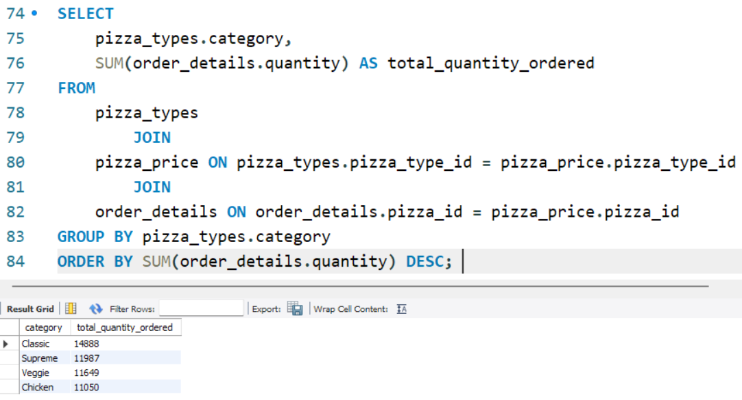

We do not observe any significant difference in category of pizzas ordered.

1. Determine the distribution of orders by hour of the day.

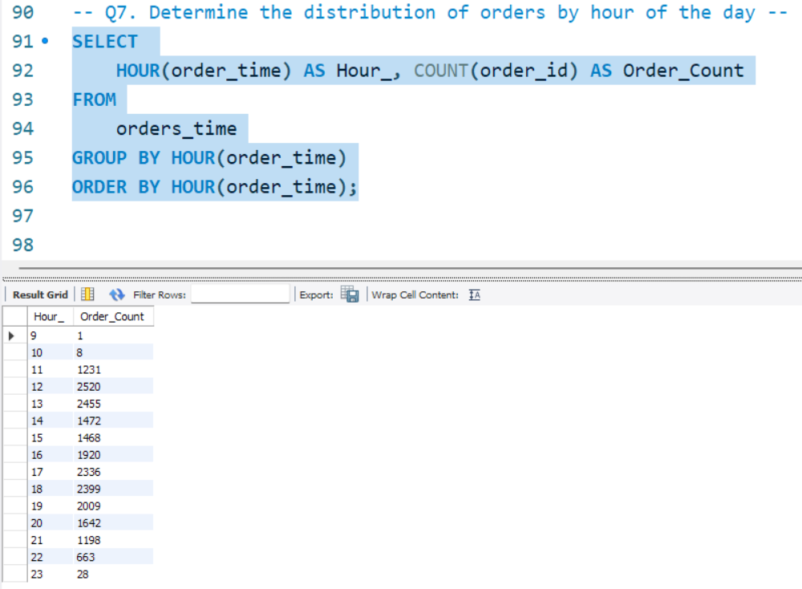

There are 2 time period of peak sales in a day. One is from 12pm to 2pm and second one is from 5pm to 8pm. Management should ensure adequate staff during these times of the day.

1. Join relevant tables to find the category-wise distribution of pizzas.

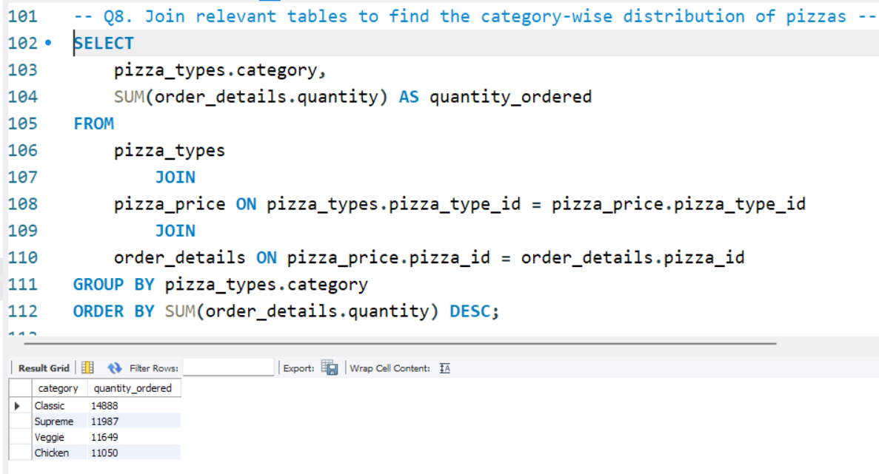

1. Group the orders by date and calculate the average number of pizzas ordered per day.

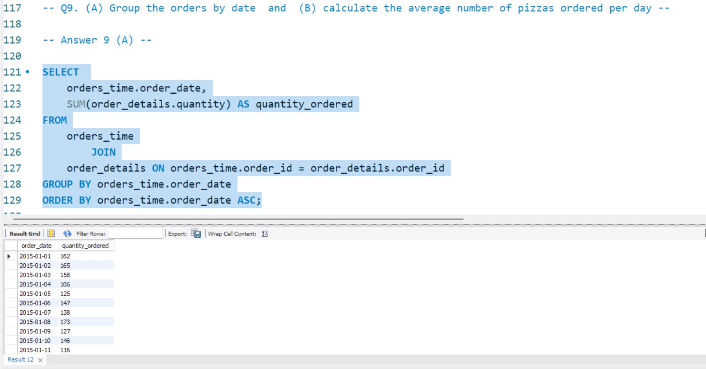

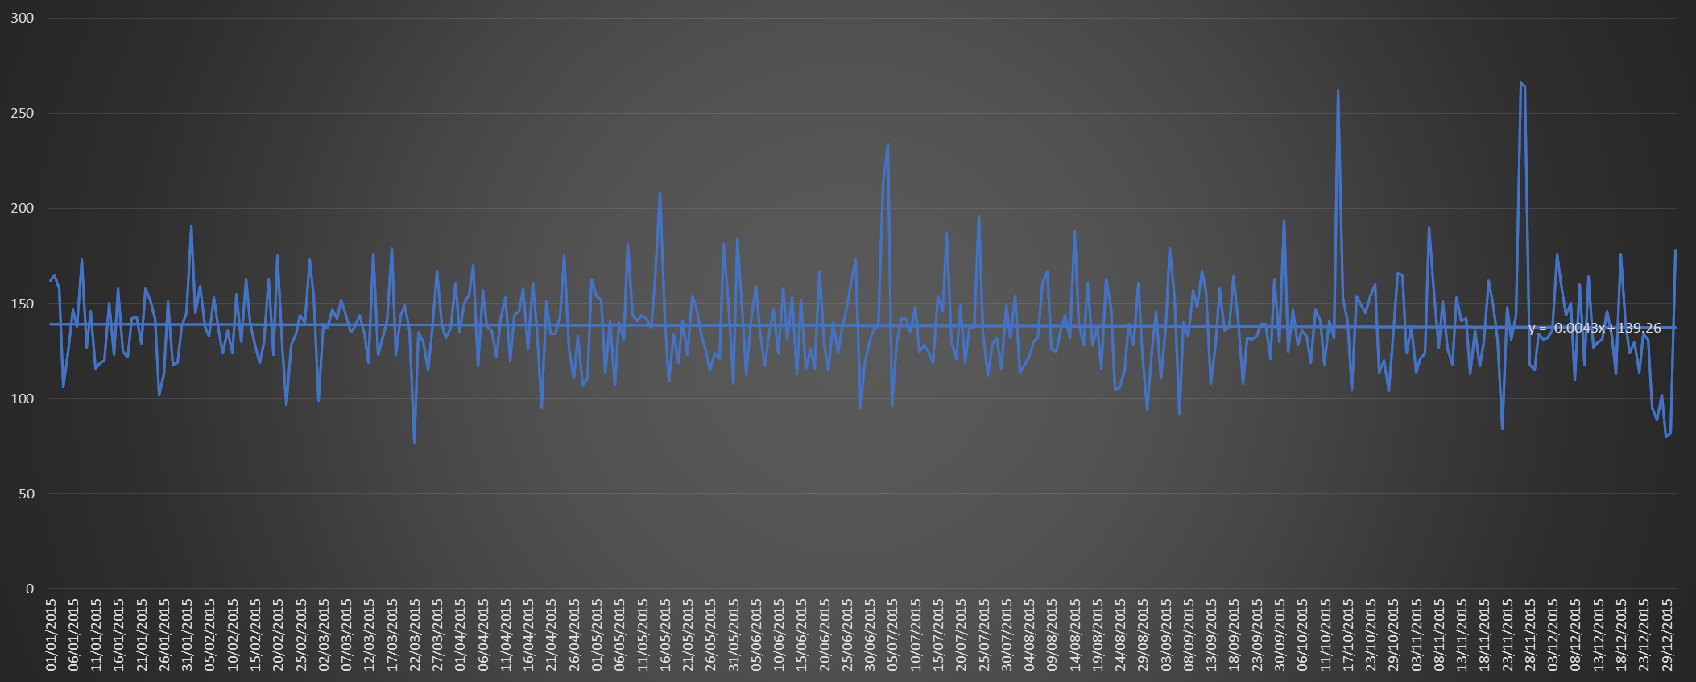

Overall the trend for sales is stable, sales is neither increasing nor decreasing. There is fluctuation in sales on holidays and festivals.

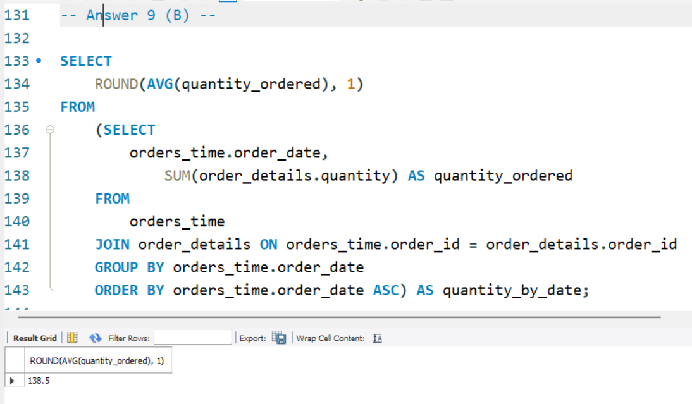

On average orders placed daily are 139 orders.

1. Determine the top 5 most ordered pizzas based on revenue.

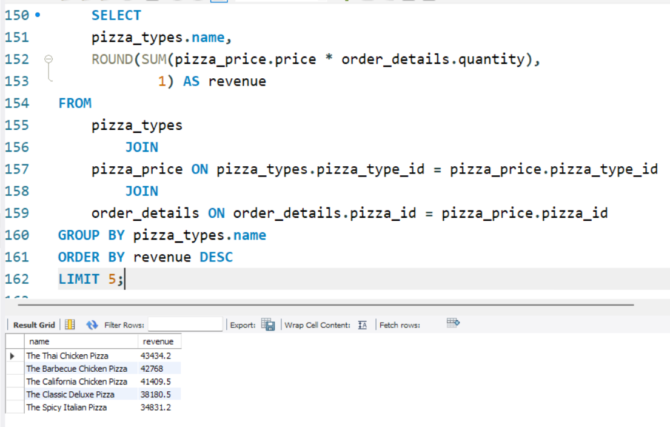

1. Calculate the percentage contribution of each pizza type to total revenue.

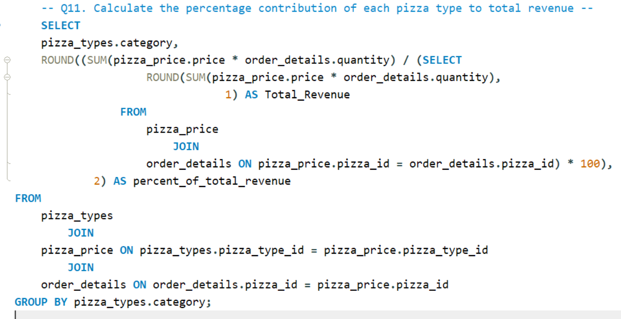

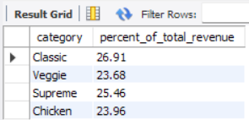

All 4 categories have approximately same contribution to revenue.

1. Analyze the cumulative revenue generated over time.

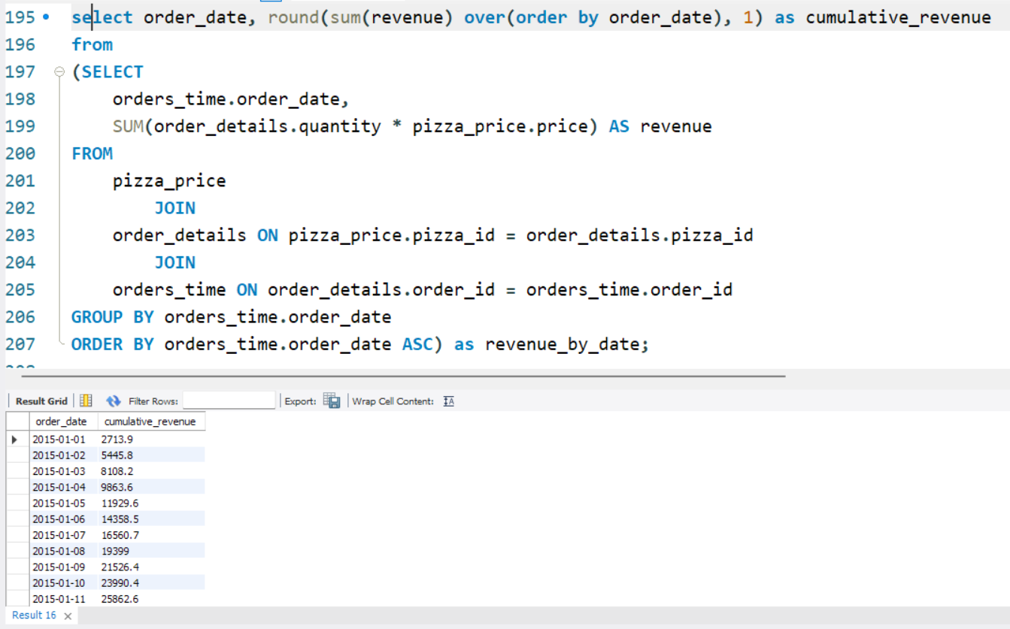

1. Determine the top 3 most ordered pizza types based on revenue for each pizza category.

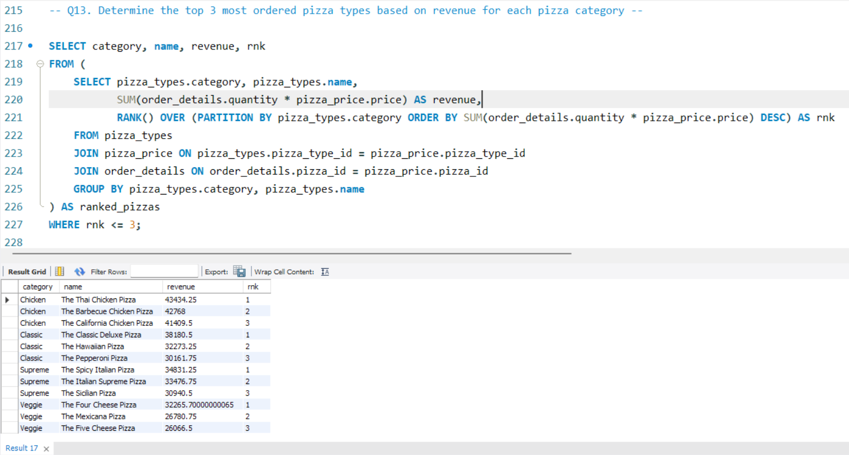

1. Identify the average quantity of pizzas ordered per order

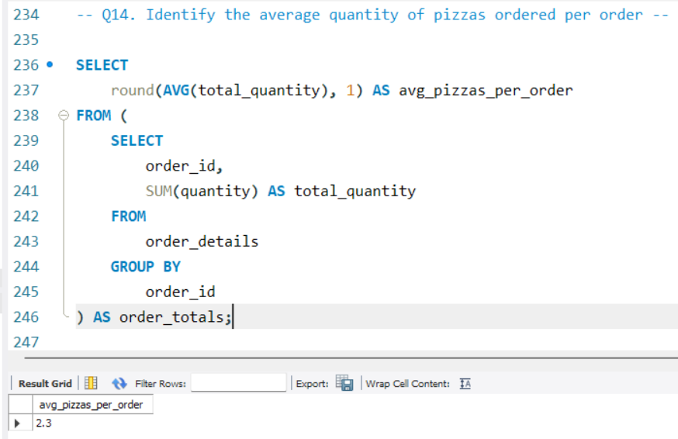

1. Analyze which combination of pizza size and category has highest contribution to our revenue

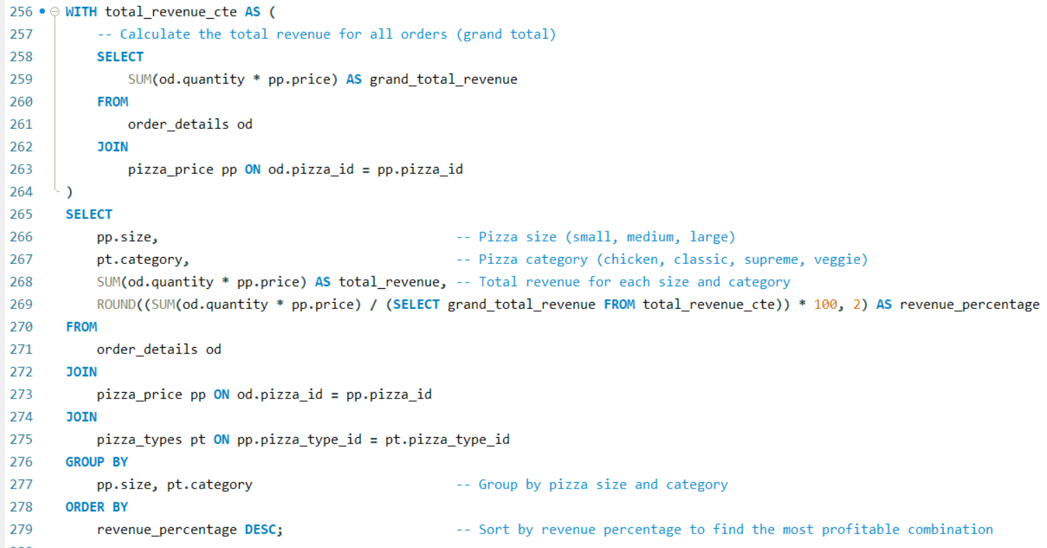

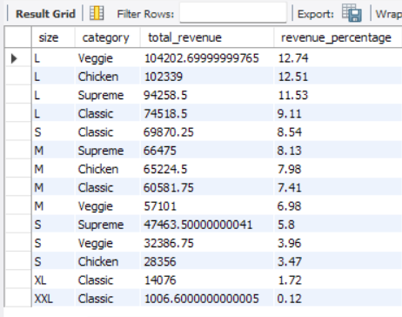

1. Analyze the trend of orders over time (average order quantities and revenue)

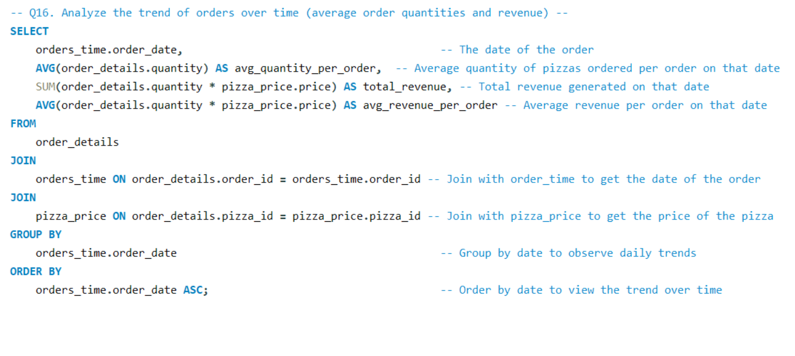

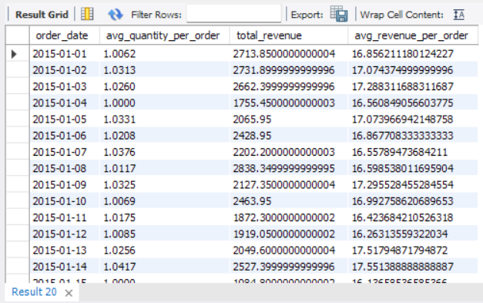

**Recommendations: -**  
The most preferred size is “L”, so team should ensure that all pizzas in the menus are available in “L” size.  
  
The 5 most profitable and commonly ordered pizzas are – 1. The classic deluxe pizza 2. The chicken barbeque pizza 3. The Hawaiian pizza 4. The pepperoni pizza 5. The Thai chicken pizza.  
Consider adjusting the price of these top 5 pizzas, particularly if they are high in demand but underpriced compared to their profitability. You can increase prices marginally, as customers are likely willing to pay more for their favorite pizzas. Small price increases on popular items often go unnoticed by customers but can significantly boost revenue due to the high volume of sales.  
Promote Add-Ons with Popular Pizzas. Suggest additional toppings, sides, or upsells when customers order these top 5 pizzas. For example, offer premium toppings, extra cheese, or garlic bread with these popular pizzas. Profit Impact: Upselling complementary products enhances the overall order value without significantly increasing costs, leading to higher margins.

Based on the finding that peak sales occur between 12pm to 2pm and 5pm to 8pm, team should ensure that the restaurant is fully staffed during peak times to handle the increased order volume. Conversely, reduce staff during off-peak hours to minimize labor costs. Improved customer service and reduced wait times during peak hours, while cutting labor costs during slower periods can slightly increase profit.

We have not observed any overall trend for increasing or decreasing pizza sales. So owner Mr. Moe does not have to worry about falling sales and going out of business. We did observe fluctuation in demand, for example on 26th November the demand was 266 orders, even though the average daily order is 139 the demand can increase during holidays and team should design kitchen and keep staff for as much as 280 orders per day, to reduce the risk of opportunity lost cost.